



Abstract: Flooding is a recurring and devastating natural disaster that severely impacts urban areas, especially in cities like Mumbai, Maharashtra. This research aims to develop a robust flood prediction system specifically for Mumbai city, The primary objectives of this review are to develop a flood prediction model that integrates historical data with real-time inputs, evaluate the model’s accuracy in predicting flood risk zones and provide safe shortest evacuation routes for affected populations. The methodology involves collecting and analyzing historical and real-time inputs such as rainfall, elevation,, water flow, soil type, land use, and population density. Advanced machine learning models are employed to classify regions into low, medium, and high flood-risk zones. A risk-aware evacuation routing module is integrated to assist communities in identifying safe evacuation paths while avoiding flood-prone areas. After analysis, we obtained results indicating that the proposed Voting Ensemble model significantly outperforms existing machine learning models achieving an impressive precision of 0.81 and a recall of 0.83. Risk-aware routing reduces exposure index by 28% and average evacuation time by 16% compared to static shortest paths, and routing times enabling near-real-time municipal deployment.

G H RAISONI COLLEGE OF ENGINEERING AND MANAGEMENT, NAGPUR
(Formerly Known as G H Raisoni Institute of Engineering & Technology)
DEPARTMENT OF COMPUTER SCIENCE AND ENGINEERING
“An AI-Based Flood Risk Early Warning System for Urban Environments: A Case Study of Mumbai”
Name of the Student’s: 1. Adil Khan 2. Anshika Arya 3. Akash Keote 4. Alfiya Qureshi 5. Amey Bhiogade
Name of the Guide’s: Ms Antara Bhattacharya,
Session: 2025-2026
Program Outcome (PO’s) and Program Specific Outcome (PSO’s)
PO’s |  |  |  |  |  |  |  |  |  |  |  |  |  |  | PSO’s
1 | 2 | 3 | 4 | 5 | 6 |  | 7 | 8 |  | 9 | 10 | 11 | 12 | 1 |  | 2 | 3
3 | 3 | 3 | 3 | 3 | 3 |  | 3 | 2 |  | 2 | 2 | 2 | 2 | 3 |  | 3 | 2
1 - Low; 2 - Medium; 3 - High
Name of Student |  |  |  |  |  | Sign |  |  | Name & Sign of Guide
ADIL KHAN |  |  |  |  |  |  |  |  | Ms. Antara Bhattacharya  Associate Professor, CSE Department
ANSHIKA ARYA
AKASH KEOTE
ALFIYA QUERESHI
AMEY BHIOGADE



Implementation:


Fig 1:- Flood Management System Overview

References:
[1]Dandekar, S., et al. (2025). A Radar Data-Driven AI Approach for Rainfall Nowcasting: Towards Flood Preparedness in Urban Regions. Journal of the Indian Society of Remote Sensing, 53, 2267–2284. https://doi.org/10.1007/s12524-025-02143-w
[2]Shahapur S.S., Eldho T.I. & Rao E.P. (2011). Flood Simulation in an Urban Catchment of Navi Mumbai City with Detention Pond and Tidal Effects Using FEM, GIS, and Remote Sensing. Journal of Waterway, Port, Coastal, and Ocean Engineering, 137(6). https://doi.org/10.1061/(ASCE)WW.1943-5460.0000093.
[3] Solanki, Y. P., Kumar, V., Sharma, K. V., Deshmukh, A., & Tiwari, D. K. (2024). Flood hazard analysis in Mumbai using geospatial and multi-criteria decision-making techniques. Journal of Water and Climate Change, 15(5), 2484. https://doi.org/10.2166/wcc.2024.053.

Conclusion and Future scope:
This research demonstrates that combining AI-based flood forecasting with GIS-driven evacuation routing can significantly enhance urban disaster preparedness. The ensemble model reliably predicted flood-prone zones in Mumbai, while the risk-aware routing algorithm optimized evacuation by reducing hazard exposure and travel time. The system, integrated with automated alerts and cloud deployment, is scalable to other Indian cities. Overall, this framework provides a proactive, real-time, and operational solution for mitigating flood impacts in urban areas.
Future enhancements include IoT-based real-time sensors, SAR integration, and collaboration with municipal authorities for deployment.

Introduction:
Flooding remains one of the most destructive natural disasters, and in urban regions, its impact is magnified by rapid urbanization, population growth, and inadequate drainage systems. Mumbai, as a coastal megacity, experiences severe flooding almost every monsoon, leading to loss of life, property damage, transport disruption, and large-scale economic setbacks. The city's vulnerability is exacerbated by its old and inadequate drainage system,which was originally designed for a much lower rainfall capacity and is now overwhelmed by intense monsoon downpours .Although meteorological and hydrological data are available, there is no unified system that can forecast flood risk in real time while also guiding safe evacuation measures for residents..
Addressing this problem necessitates the development of an advanced flood prediction model tailored specifically for Mumbai city, that not only forecasts high, medium, and low-risk flood zones using ensemble learning models but also integrates GIS-based visualization, risk-aware evacuation routing, and an automated multi-channel alerting system. By combining prediction, mapping, routing, and communication in a single framework, the system aims to provide a holistic and operationally viable solution for enhancing urban flood resilience

UI / UX Design:
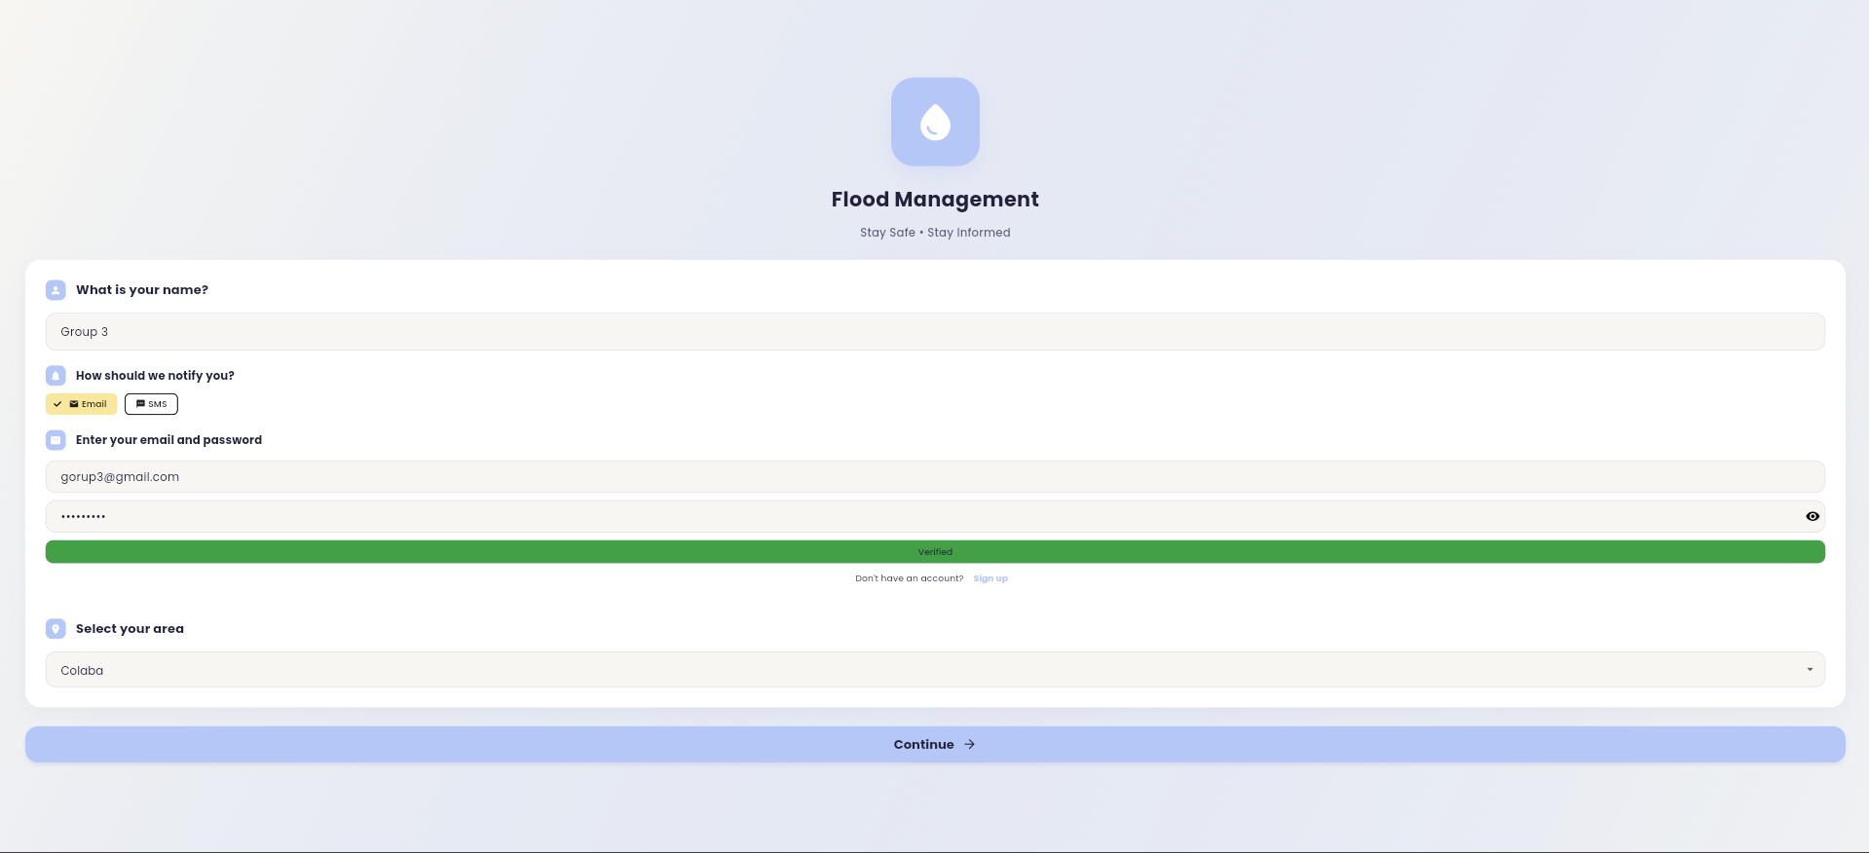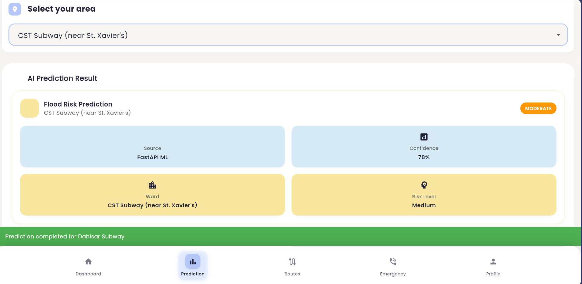
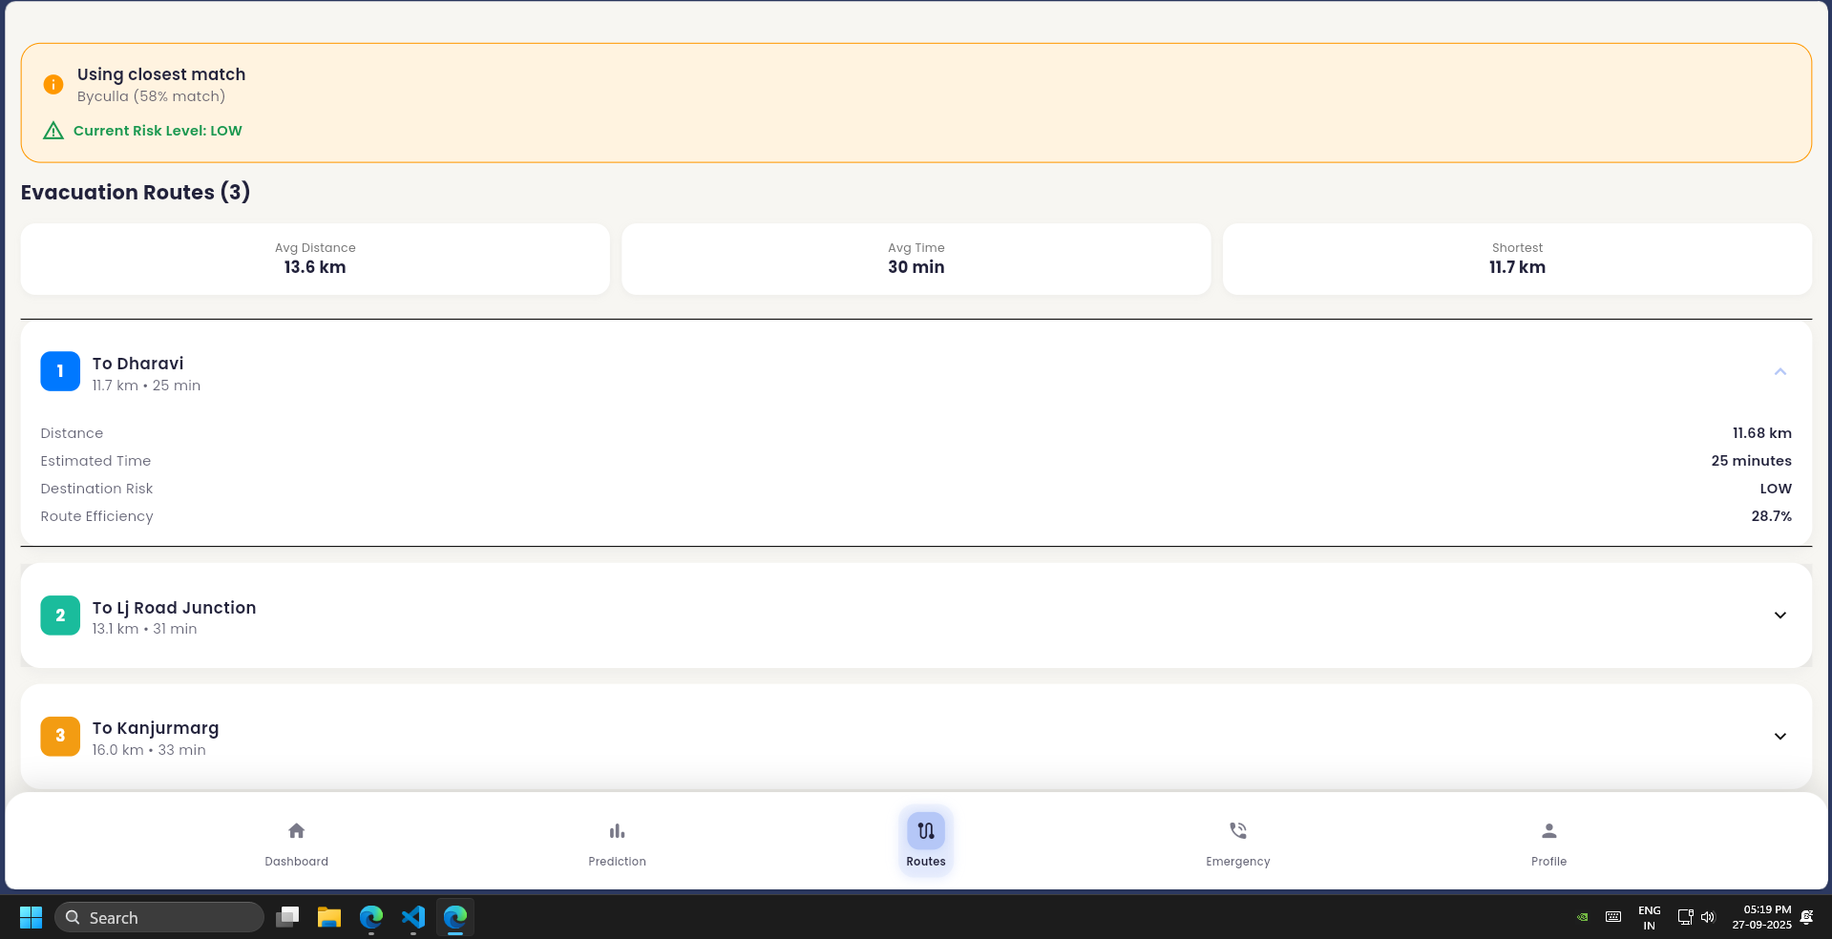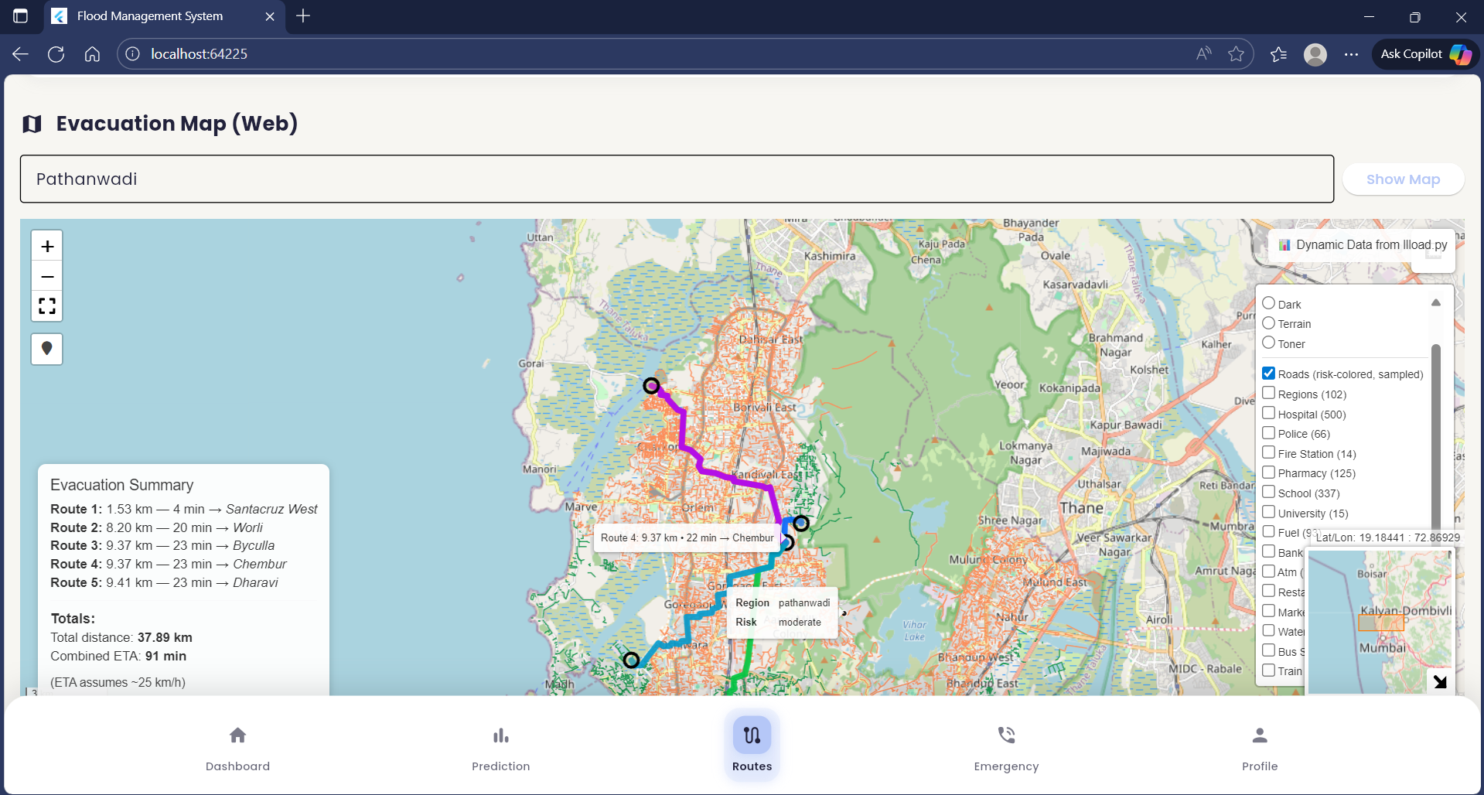

Results:

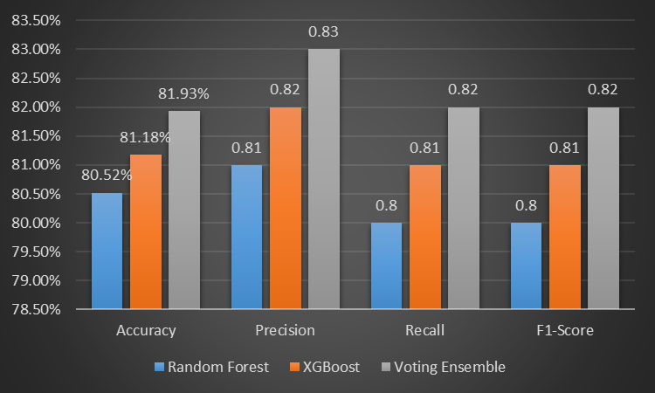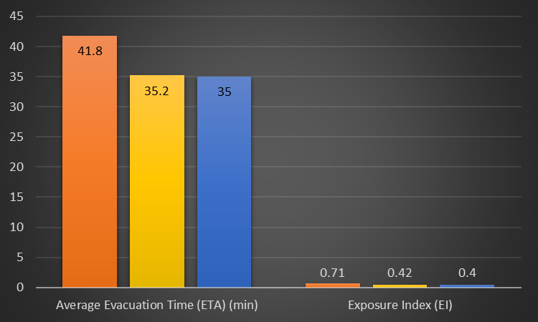
Figure 2 : Model Performance Comparison Figure 3: Performance of Routing Methods

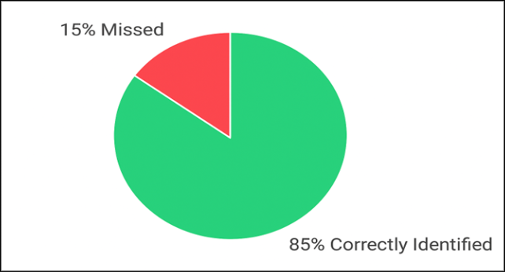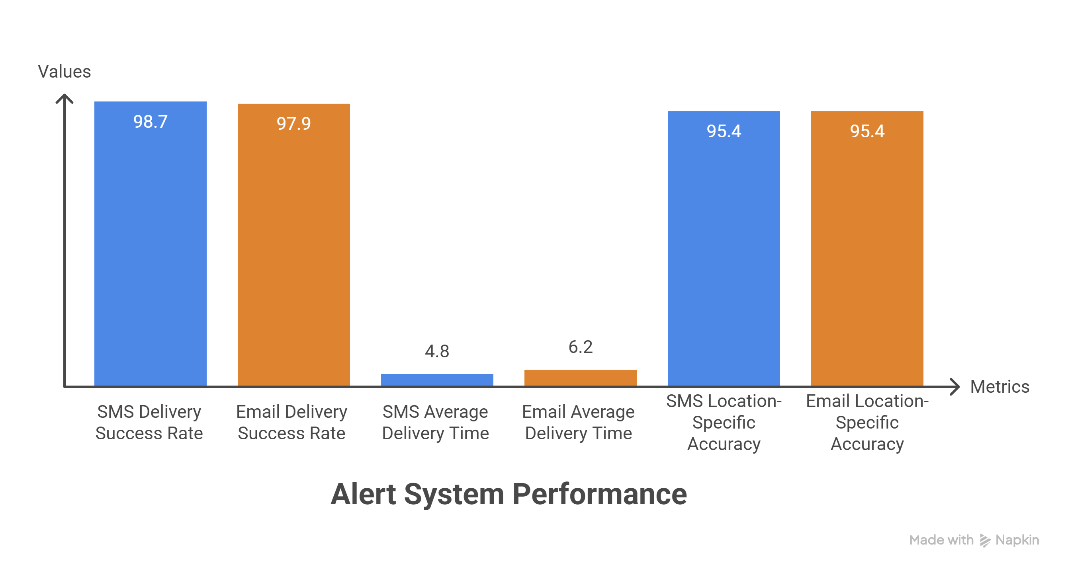
Figure 4: High-Risk Event Detection Figure 5: Alert System Performance

